**Smart - kargo Shopify API**

- We confirm our error there we observe some properties are deprecated In latest version of shopify.

- We confirm our api version for webhooks, there we use ‘ 2021-10 ‘ and when we confirm that documentation we get below response

URL: <https://shopify.dev/docs/api/release-notes/2021-01>

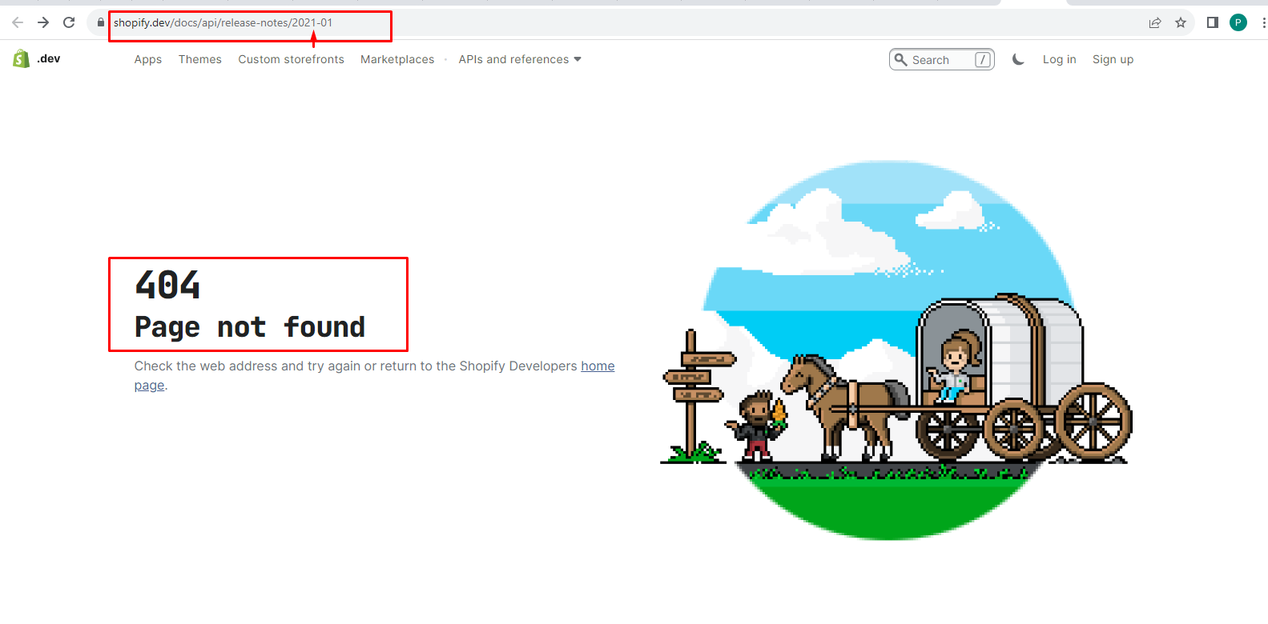

- Our current version is ‘ 2023-10 ‘ , in this version that property are deprecated.

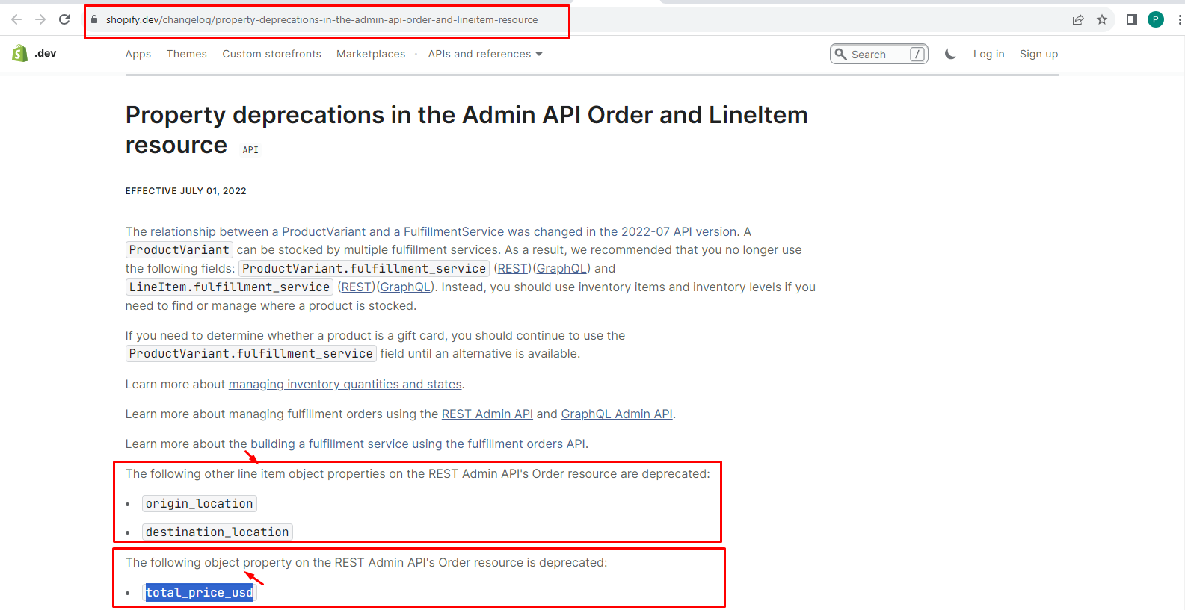

- The following other line item object properties on the REST Admin API's Order resource are deprecated:

1. Origin_location
2. Destination_location

Url : It coming through the order API. It returns from the order resources API.

- We confirm url response there we get origin_location line item property, so we not use this line item object property in resources API.

- We also confirm destination_location parameter but we not found that line item object property in url.

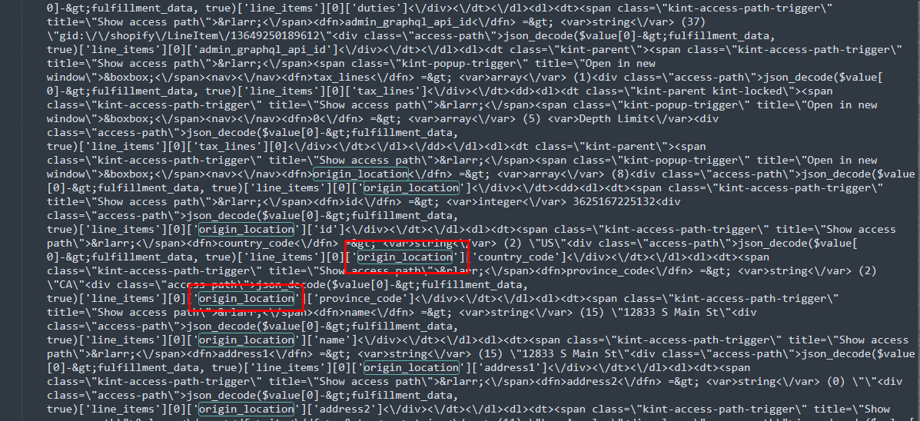

- We not use this line item object property.

- The following object property on the REST Admin API's Order resource is deprecated:

1. Total_price_usd

Url: /admin/api/2022-10/orders/450789469.json (PUT)

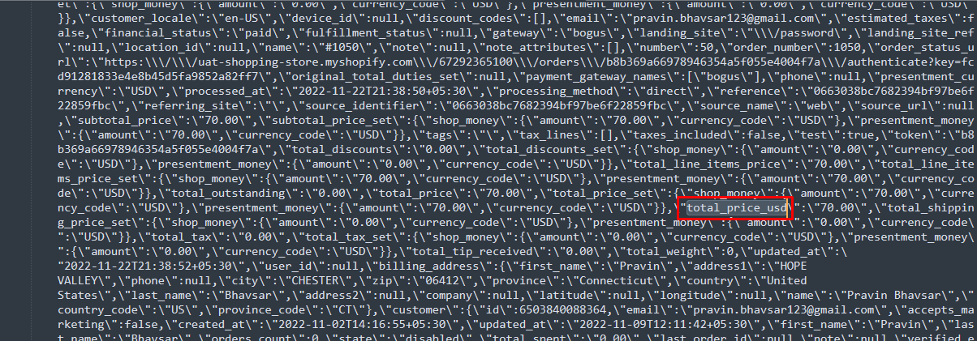

- We confirm our url response there we get total_price_usd object property, so we not use this object property .

- When our order is update that time we not need to upate that object property.

**We Used below documentation to find out the API:**

Old - <https://shopify.dev/docs/api/admin-rest/2022-10/resources/order#resource-object>

New - <https://shopify.dev/docs/api/admin-rest/2023-07/resources/order#post-orders>

